Topology Overview & Design

SKILL 08 – Lesson 03
Understanding Basic Interface Counter

This deployment guide describes the step-by-step implementation of the network infrastructure named "The First Coffee Shop" within Cisco Packet Tracer. The network is configured using a single Class C subnet spanning 192.168.1.0/24, allowing for up to 254 assignable host addresses. The physical layer design utilizes high-speed Ethernet interfaces and implements EtherChannel link aggregation to optimize switch-to-switch trunk bandwidth and introduce link level redundancy.
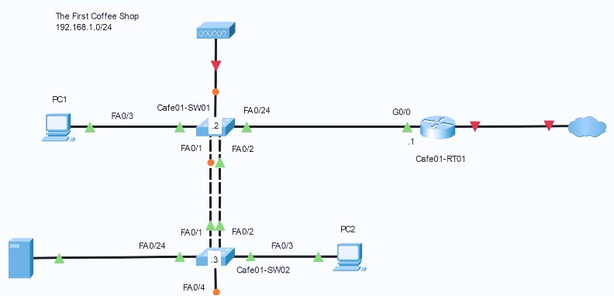
Figure 1.1: Packet Tracer Network Logical Topology Diagram.

Addressing and Interface Architecture Matrix

The following table outlines the complete structural breakdown of device interfaces, hostnames, and IP address scopes required to build the infrastructure illustrated above.

Device Hostname | Device Type | Interface | IP Address | Subnet Mask / VLAN | Default Gateway
Cafe01-RT01 | Router (e.g., ISR 4331) | G0/0 | 192.168.1.1 | 255.255.255.0 | N/A
Cafe01-SW01 | Switch (2960) | VLAN 1  (Management) | 192.168.1.2 | 255.255.255.0 | 192.168.1.1
Cafe01-SW02 | Switch (2960) | VLAN 1  (Management) | 192.168.1.3 | 255.255.255.0 | 192.168.1.1
PC1 | End Device | FastEthernet0 | 192.168.1.10 | 255.255.255.0 | 192.168.1.1
PC2 | End Device | FastEthernet0 | 192.168.1.11 | 255.255.255.0 | 192.168.1.1
Server | End Device | FastEthernet0 | 192.168.1.20 | 255.255.255.0 | 192.168.1.1

Note on EtherChannel Configuration: The parallel connections between Cafe01-SW01 and Cafe01-SW02 across interfaces FA0/1 and FA0/2 must be explicitly grouped into a logical Link Aggregation Group (LAG) to prevent Spanning Tree Protocol (STP) blocking loops.

Step-by-Step Deployment Instructions

Step 3.1: Deploy Network Nodes to Workspace
- Launch Cisco Packet Tracer.
- From the bottom-left Device Selection Box, drag one Router (such as the ISR 4321 or 2911 model) into the workspace and change its display name to Cafe01-RT01.
- Drag two 2960 Catalyst Switches into the workspace. Label the upper switch Cafe01-SW01 and the lower switch Cafe01-SW02.
- Place two End Device PCs (labeled PC1 and PC2) and one Generic Server asset onto the panel according to the reference blueprint.

Step 3.2: Complete Cabling Connections
Using the connection tool select the required physical mediums:

  - Copper Straight-Through Cable: Connect PC1 (Fa0) to Cafe01-SW01 (Fa0/3).
  - Copper Straight-Through Cable: Connect Cafe01-RT01 (G0/0) to Cafe01-SW01 (Fa0/24).
  - Copper Cross-Over Cables / EtherChannel Pair: Connect Cafe01-SW01 (Fa0/1) to Cafe01-SW02
(Fa0/1) AND connect Cafe01-SW01 (Fa0/2) to Cafe01-SW02 (Fa0/2).
  - Copper Straight-Through Cable: Connect Cafe01-SW02 (Fa0/3) to PC2 (Fa0).

  - Copper Straight-Through Cable: Connect Cafe01-SW02 (Fa0/24) to the Server (Fa0).

Step 3.3: Configure the Default Gateway (Cafe01-RT01)
Click on Cafe01-RT01, navigate to the CLI tab, and execute the following configuration commands:
Router> enable
Router# configure terminal Router(config)# hostname Cafe01-RT01
Cafe01-RT01(config)# interface GigabitEthernet0/0
Cafe01-RT01(config-if)# ip address 192.168.1.1 255.255.255.0 Cafe01-RT01(config-if)# no shutdown
Cafe01-RT01(config-if)# exit Cafe01-RT01(config)# exit

Step 3.4: Configure Switch 1 with EtherChannel (Cafe01-SW01)
Access the CLI of Cafe01-SW01 to assign the management IP address and cluster the uplink interfaces into an active trunk port group channel:
Switch> enable
Switch# configure terminal Switch(config)# hostname Cafe01-SW01
Cafe01-SW01(config)# interface range FastEthernet0/1 - 2 Cafe01-SW01(config-if-range)# channel-group 1 mode desirable Cafe01-SW01(config-if-range)# exit
Cafe01-SW01(config)# interface port-channel 1 Cafe01-SW01(config-if)# switchport mode trunk Cafe01-SW01(config-if)# exit
Cafe01-SW01(config)# interface vlan 1
Cafe01-SW01(config-if)# ip address 192.168.1.2 255.255.255.0 Cafe01-SW01(config-if)# no shutdown
Cafe01-SW01(config-if)# exit
Cafe01-SW01(config)# ip default-gateway 192.168.1.1

Step 3.5: Configure Switch 2 with EtherChannel (Cafe01-SW02)
Mirror the physical group configurations on Cafe01-SW02 to successfully initialize the load-balancing link aggregation state:

Switch> enable
Switch# configure terminal Switch(config)# hostname Cafe01-SW02
Cafe01-SW02(config)# interface range FastEthernet0/1 - 2 Cafe01-SW02(config-if-range)# channel-group 1 mode desirable Cafe01-SW02(config-if-range)# exit
Cafe01-SW02(config)# interface port-channel 1 Cafe01-SW02(config-if)# switchport mode trunk Cafe01-SW02(config-if)# exit
Cafe01-SW02(config)# interface vlan 1
Cafe01-SW02(config-if)# ip address 192.168.1.3 255.255.255.0 Cafe01-SW02(config-if)# no shutdown
Cafe01-SW02(config-if)# exit
Cafe01-SW02(config)# ip default-gateway 192.168.1.1

Step 3.6: Assign Host IP Addresses
Click on each individual endpoint node (PC1, PC2, and Server), navigate to the Desktop tab → IP Configuration menu option, and enter these Static Parameters:
  - PC1: IP Address = 192.168.1.10 | Subnet Mask = 255.255.255.0 | Gateway = 192.168.1.1
  - PC2: IP Address = 192.168.1.11 | Subnet Mask = 255.255.255.0 | Gateway = 192.168.1.1
  - Server: IP Address = 192.168.1.20 | Subnet Mask = 255.255.255.0 | Gateway = 192.168.1.1

Topology Verification and Troubleshooting

Once the configuration sequences are complete, verify the link health statuses across the core routing pipeline. Execute a network end-to-end connectivity ping verification test. Open the Command Prompt interface window from PC1 and verify response output reachability to the local network boundaries using:
C:\> ping 192.168.1.1
C:\> ping 192.168.1.20

If all responses indicate a 0% loss packet metric parameter value sequence, the workspace has been deployed successfully.

